./l071 -H 36 -L 30 -F easy.jpg -KS 3 -MS 115 -R 3 -MinR 80 -MaxR 120 -TC 54 -MinQ 105

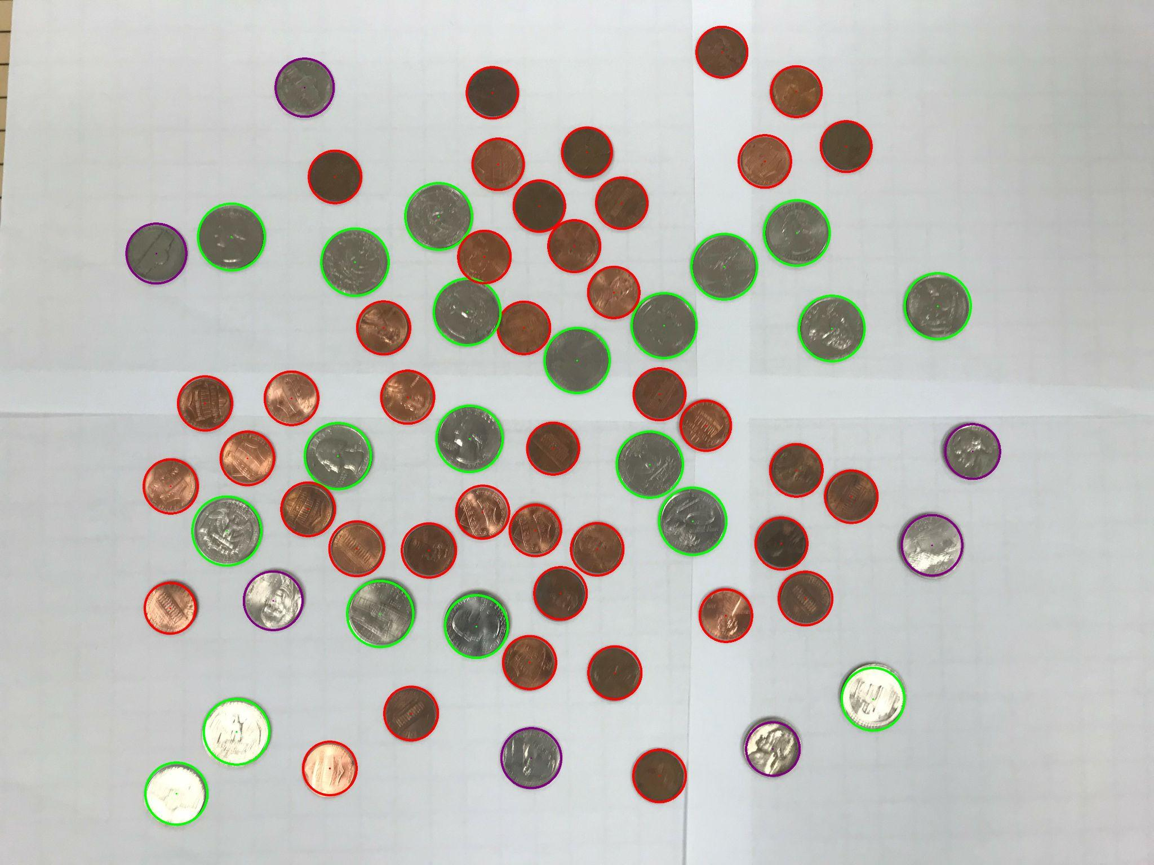

41 Pennies

7 Nickels

0 Dimes

20 Quarters

0 Silver Dollars

Total: $5.76

./l071 -H 36 -L 30 -F medium.jpg -KS 3 -MS 90 -R 3 -MinR 70 -MaxR 115 -TC 57 -MinQ 102

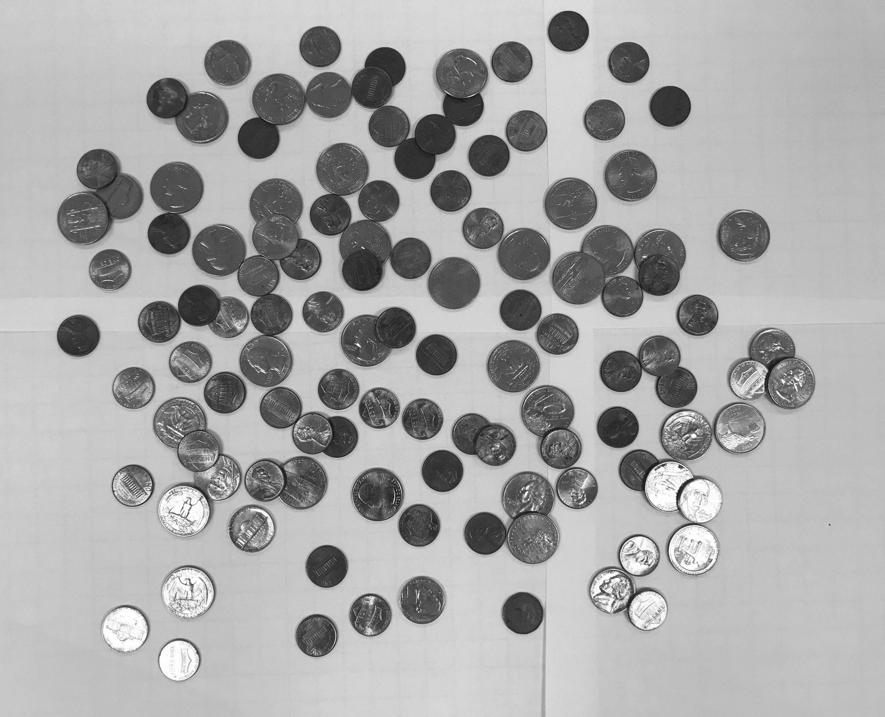

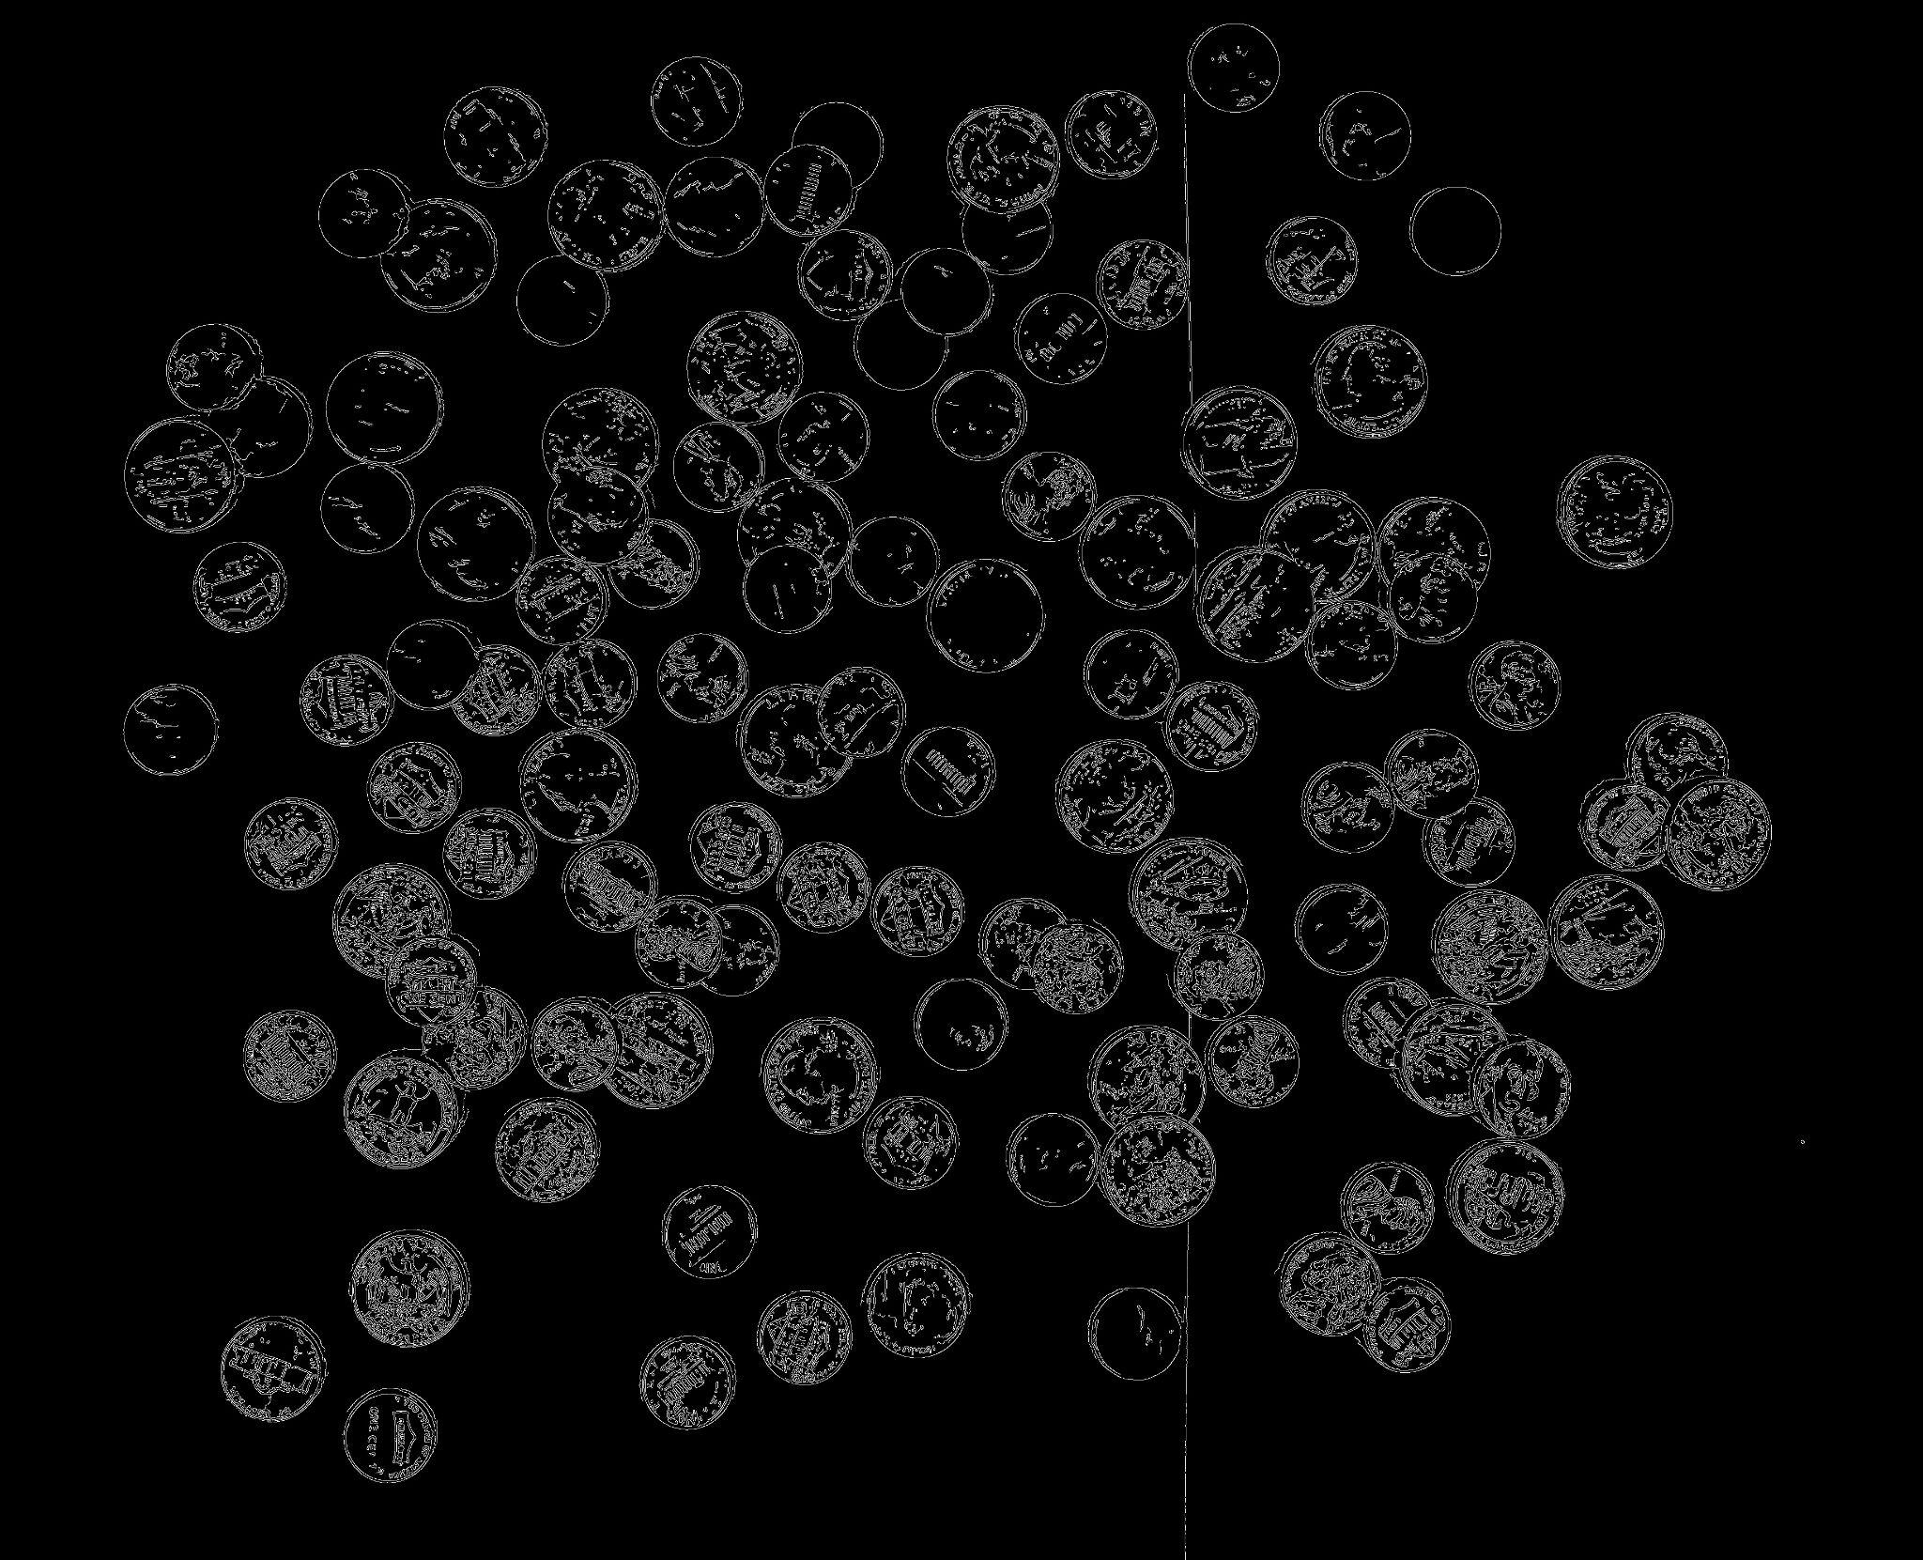

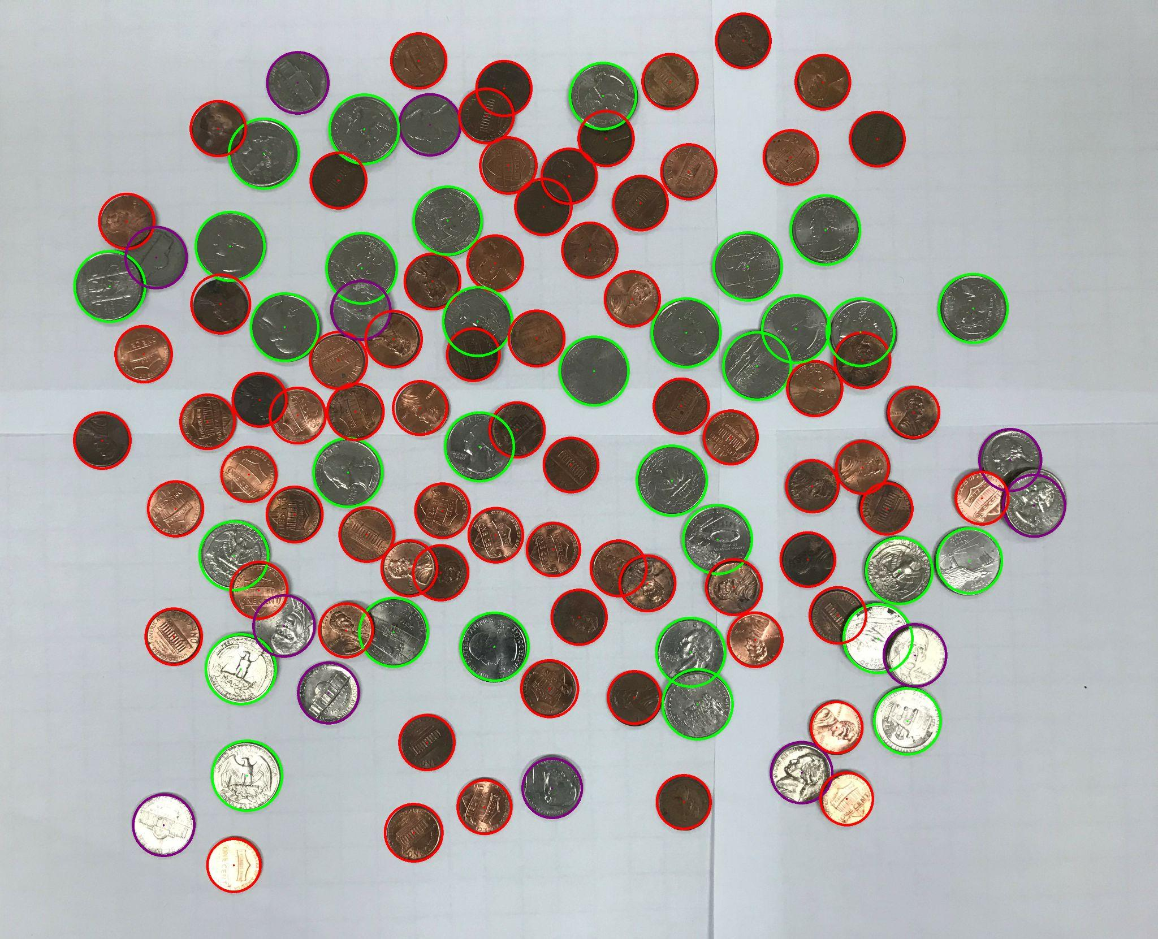

72 Pennies

12 Nickels

0 Dimes

32 Quarters

0 Silver Dollars

Total: $9.32

./l071 -H 36 -L 30 -F hard.jpg -KS 3 -MS 40 -R 3 -MinR 70 -MaxR 170 -TC 60 -MinQ 103

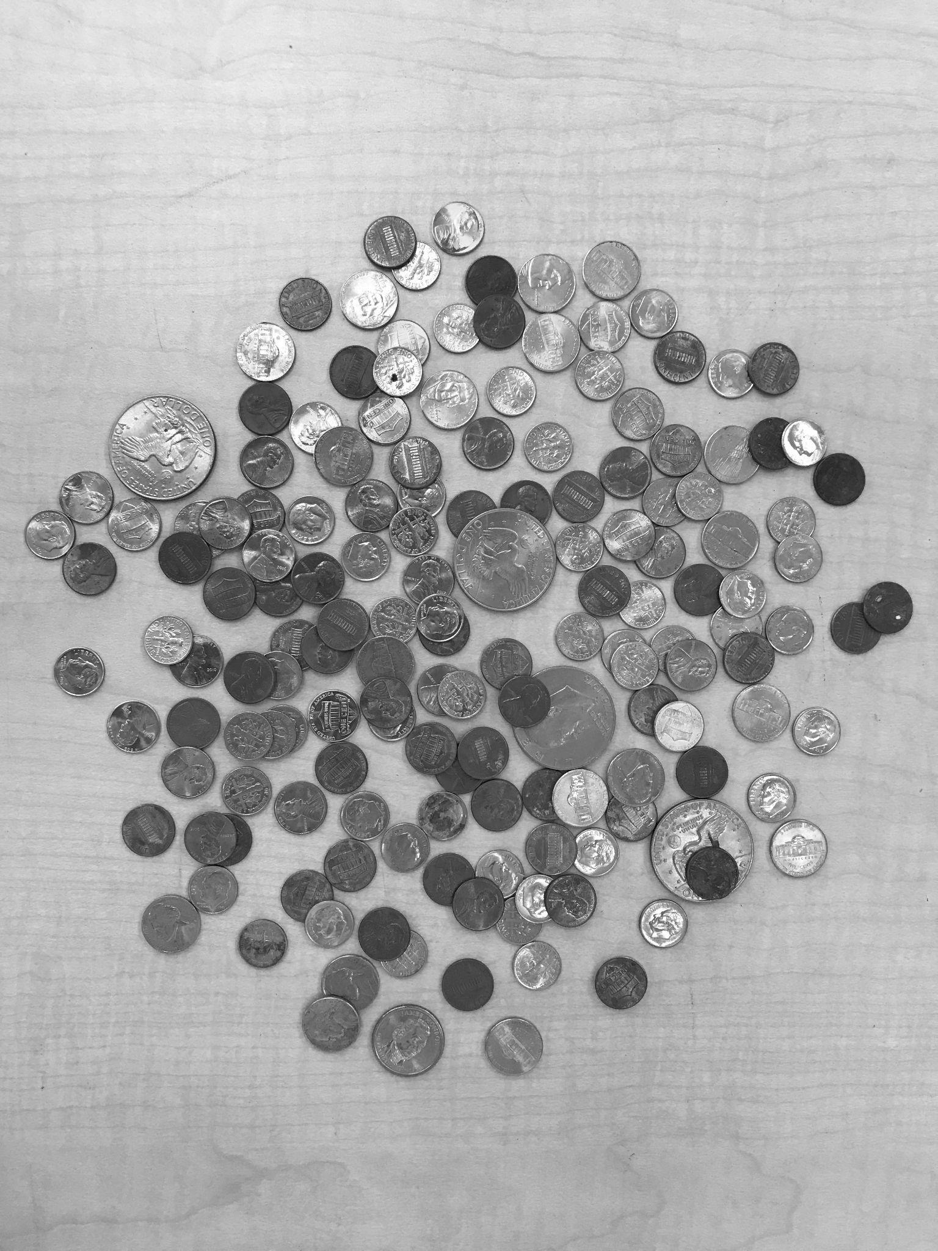

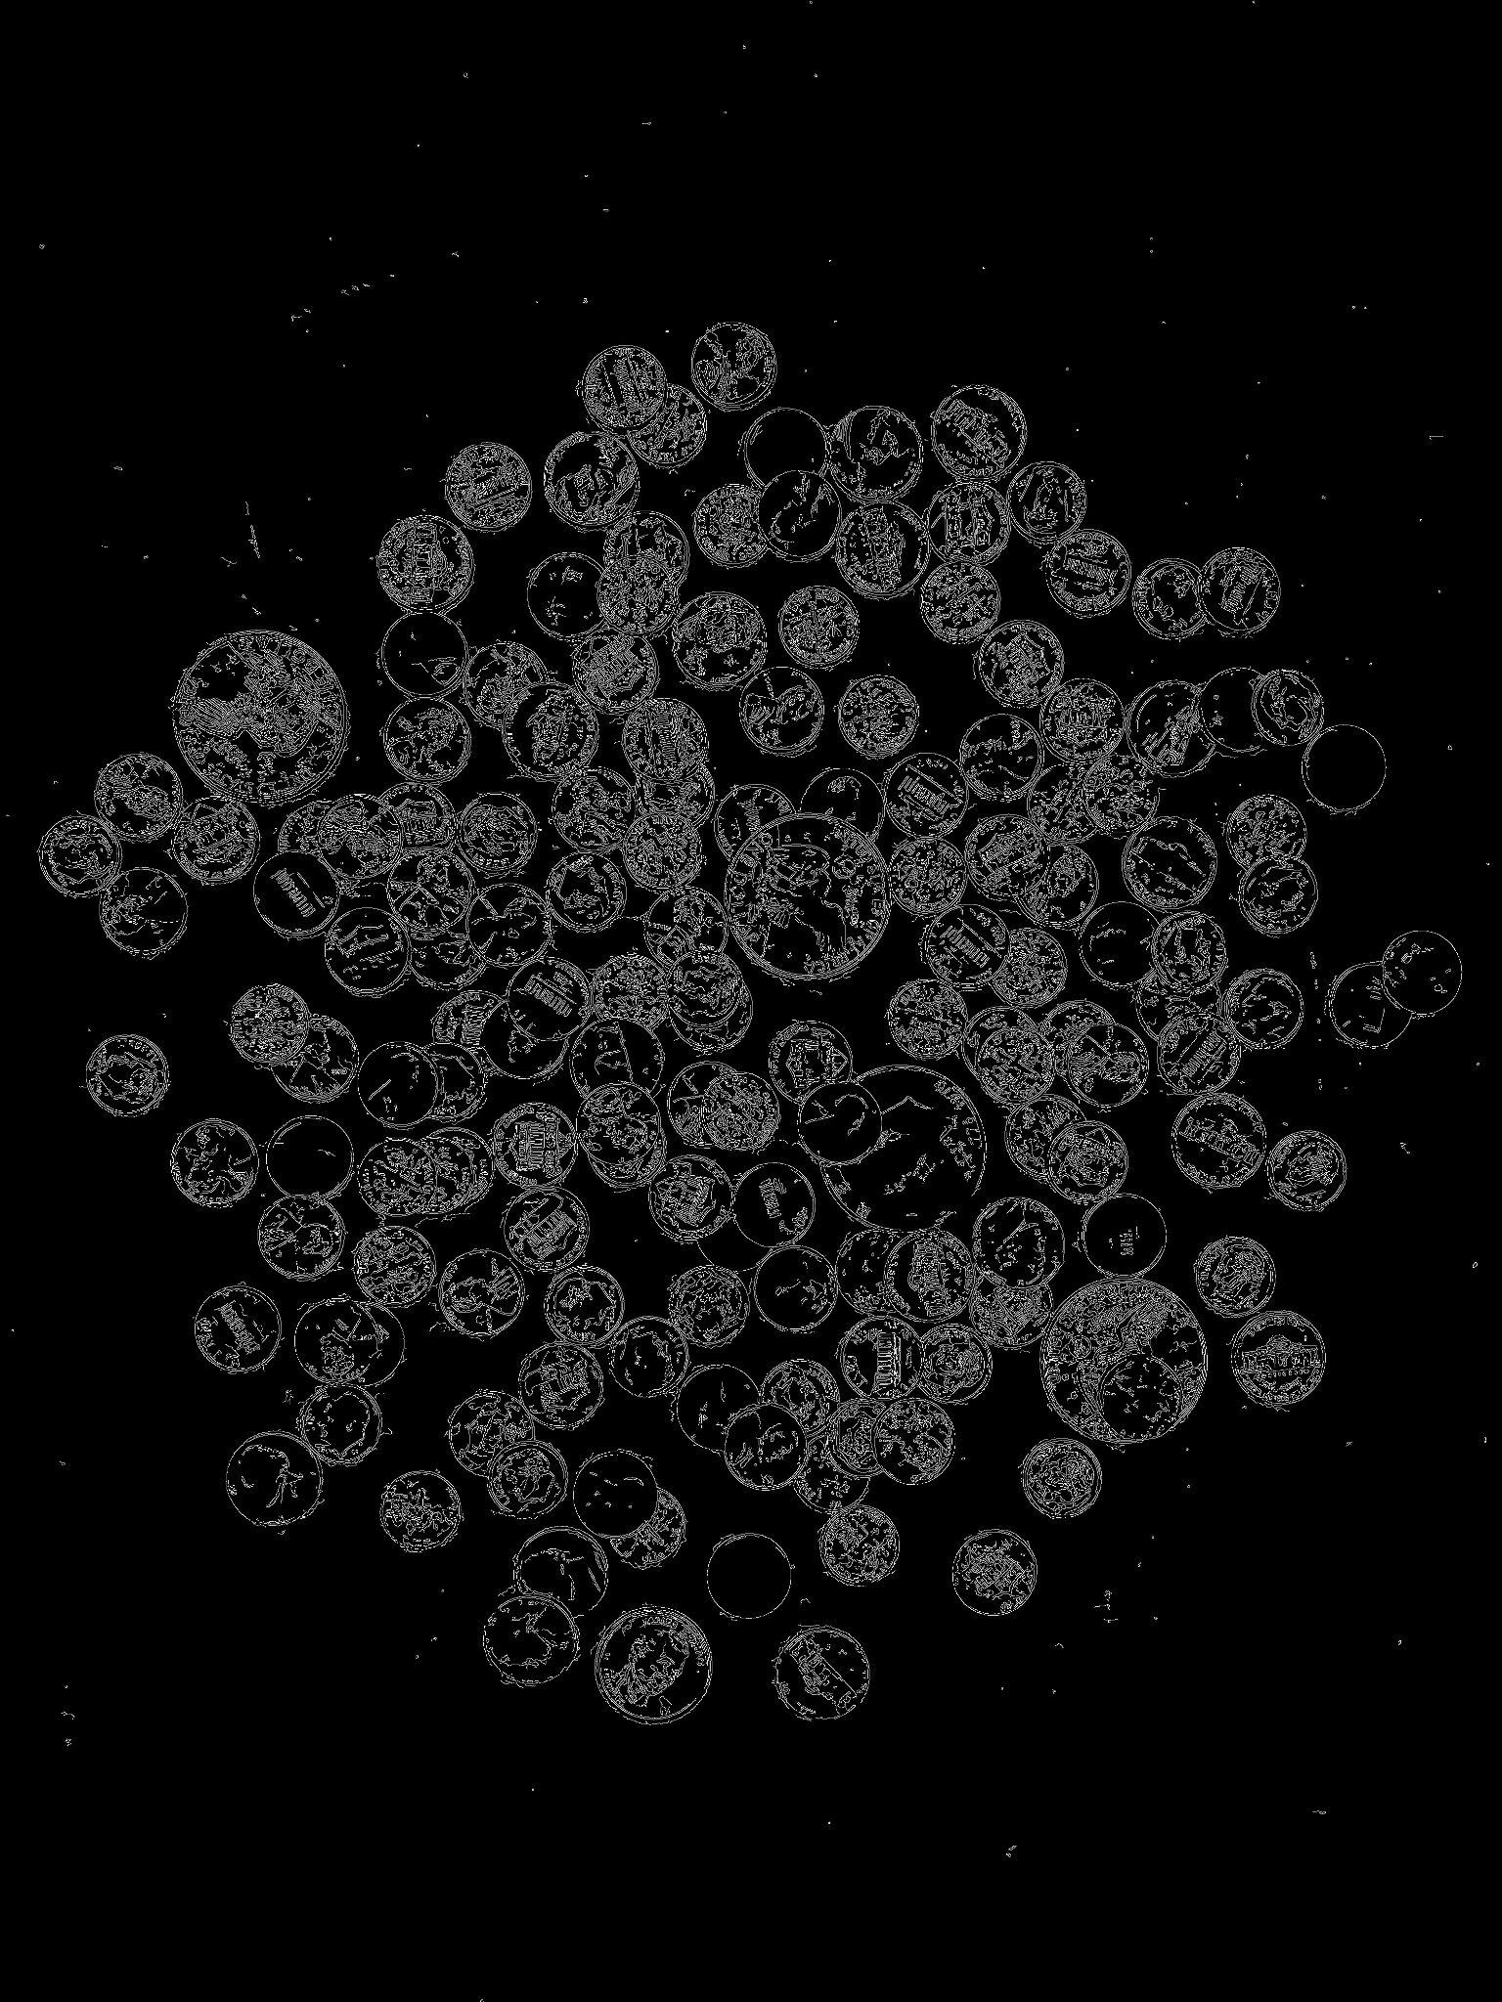

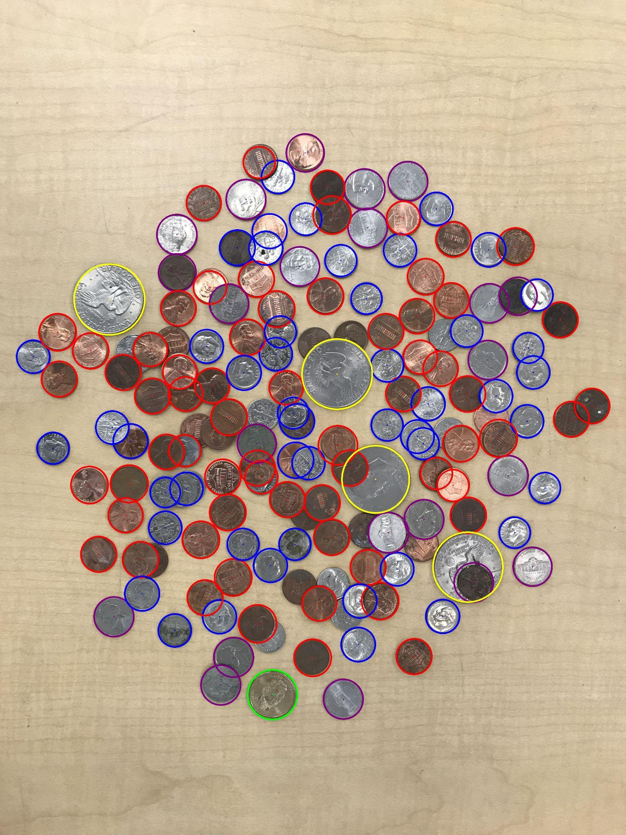

65 Pennies

22 Nickels

48 Dimes

1 Quarters

4 Silver Dollars

Total: $8.8